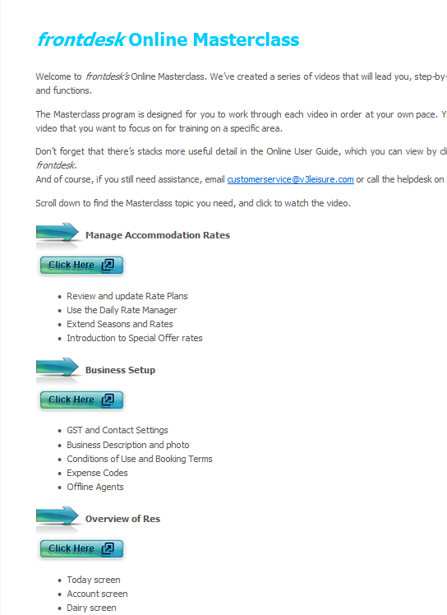
Add New Heading: “Products and Rates for Tours” (add new video ‘Products and Rates for Tour’)
. Product Overview Screen
.Create or edit Products
.Define seasonal rules and prices
Replace these points with:
. Overview of Daily Rate Manager
. Define, change or extend rates

Replace Video with“Define and Manage Rates’

Add New Heading: “Set UpSpecial Offers” (add new video ‘Special Offers’)
. Create promotional pricing using Special Offers
Add New Heading: “Accommodation Product Setup” (add new video ‘Product Setup’.
.Product Overview screen and tools
. Create or edit Products and Rooms
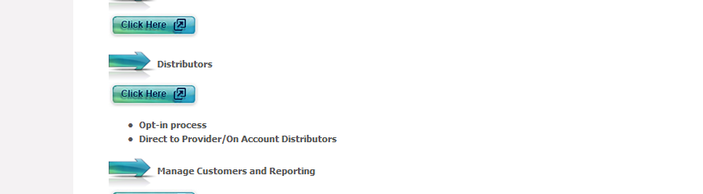
Add additional point or line something like:
“Opt-into BookEasy: Download pdf instructions”
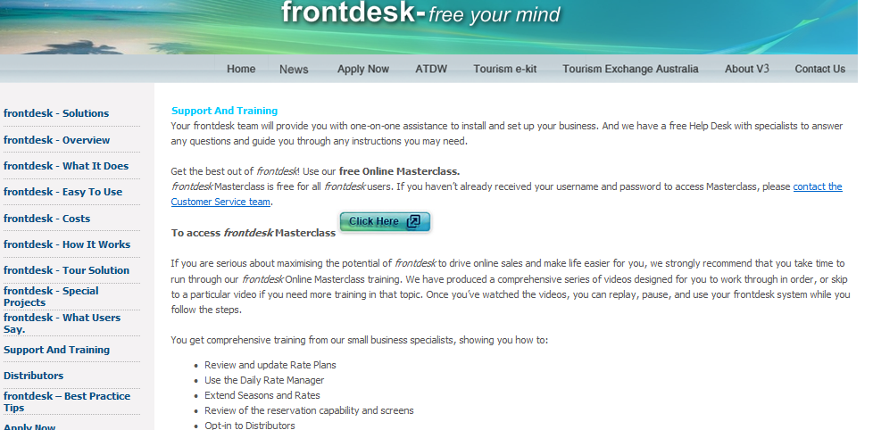
What’s new in frontdesk 3? View the video CLICK HERE
(Load ‘fd 3 overview’ video)

